Day 14

SUM OF THE DIGIT USING RECURSION:
CODE:
import java.util.*;
public class sum{
static int SumofDigit(int n){
if(n==0){
return 0;
}
return(n%10) + SumofDigit(n/10);
}
public static void main(String[] args){
Scanner sc=new Scanner(System.in);
System.out.print("N: ");
int n=sc.nextInt();
System.out.print("Sum of the digits are: ");
System.out.print(SumofDigit(n));
}
}
OUTPUT:
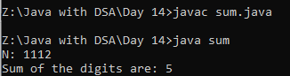
FACTORIAL USING RECURSION:
CODE:
import java.util.*;
public class fact{
static int Factorial(int n){
if(n==0 || n==1){
return 1;
}
return n*Factorial(n-1);
}
public static void main(String[] args){
Scanner sc=new Scanner(System.in);
System.out.print("N: ");
int n=sc.nextInt();
System.out.print("Factorial of the number is: ");
System.out.print(Factorial(n));
}
}
OUTPUT:
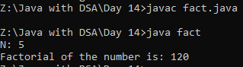
FIBONACCI USING RECURSION:
CODE:
import java.util.*;
public class fibonacci{
static int Fibo(int n){
if(n==0){
return 0;
}
if(n==1){
return 1;
}
return Fibo(n-1) + Fibo(n-2);
}
public static void main(String[] args){
Scanner sc=new Scanner(System.in);
System.out.print("N: ");
int n=sc.nextInt();
System.out.print("Fibonacci of the number is: ");
System.out.print(Fibo(n));
}
}
OUTPUT:
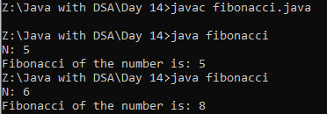
MERGE THE TWO SORTED ARRAYS:
CODE:
import java.util.*;
public class sort{
public static void main(String[] args){
Scanner sc=new Scanner(System.in);
System.out.print("N1: ");
int n1=sc.nextInt();
System.out.print("Array elements in sorted order: ");
int[] arr1=new int[n1];
for(int i=0;i<n1;i++){
arr1[i]=sc.nextInt();
}
System.out.print("N2: ");
int n2=sc.nextInt();
System.out.print("Array elements in sorted order: ");
int[] arr2=new int[n2];
for(int i=0;i<n2;i++){
arr2[i]=sc.nextInt();
}
int temp[]=new int[n1+n2];
int left=0;
int right=0;
int index=0;
while(left<n1 && right<n2){
if(arr1[left]<=arr2[right]){
temp[index++]=arr1[left];
left++;
}
else{
temp[index++]=arr2[right];
right++;
}
}
while(left<n1){
temp[index++]=arr1[left];
left++;
}
while(right<n2){
temp[index++]=arr2[right];
right++;
}
for(int a:temp){
System.out.print(a+" ");
}
}
}

OUTPUT:
